Now we are going to talk about the life cycle methods in React Native. If you want to know this topic importance or weightage then understand by the two points. First point is that whenever you create react native project then without lifecycle you could not even make it Now the thing is different if you are making a nano project of three or four page(who knows) then anything can be possible but if you are making a good project then you will need a lifecycle methods S

econd point is that when you go to React native or React js interview

0:30

then definitely two or three question will be asked to you on the life cycle methods So now you can understand its importance It is not like it is the only lesson on lifecycle there will be plenty lesson Here we will talk about theoratically part of lifecycle methods so that we can be ready for upcoming lesson that what are lifecycle methods Why to use it and phases and all.

But here many interview questions will be covered

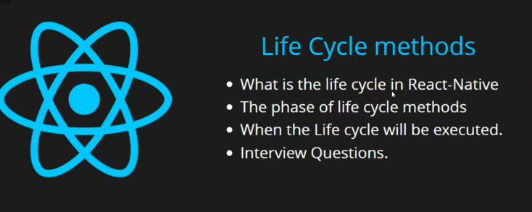

Lets start with points

First the teacher will tell that what is Lifecycle method .but before it we will understand what is lifecycle in a layman language and then we will discuss it in Reach native

Then we will talk about phases of life cycle and when they are executed how we will know it we will discuss it and at last discuss some interview question Even the points told by the teacher are like interview question in their own but still teacher will tell which are very important for our interviews

So lets start with lifecycle

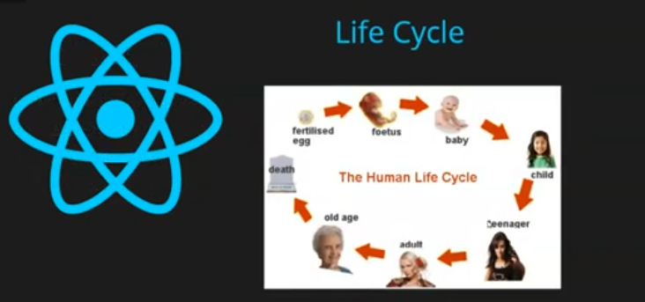

Whatever is inside this world has its own lifecycle whether there is human or any laptop or mobile

Everything have a lifecycle By lifecycle we mean something is formed and some change happens in it and it got destroyed you can see above Human Life Cycle .Everything has a lifecycle

It forms and some changes happen there and then got expired

Like a baby is born we call it the first phase of lifecycle and then in second how much we catetgorize it but in second pahse many thing happen(like marriage and have child) and in third phase death happens and inside react or react native the same cycle works

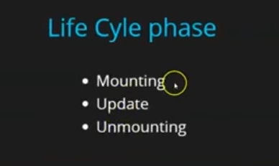

There are basically three phases in life cycle that is Mounting , Update and Unmounting

First is Mounting that is when you component get executed when you call it second is when it get updated How update will happen that you are bringing changes or updating a state or updating props Third is that we remove that component from out UI or Unmount it

By unmount we mean suppose there was a component of profile and you were showing it

And you go to setting page then our profile component get removed from our UI. So it get unmounted we call it unmount you can say it death

By this way there are three phases in lifecycle method in React or Reat Native

Now the questions come that when it will be executed

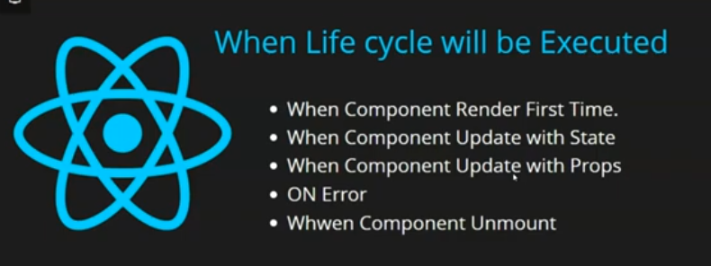

When your component will be mounted first

Suppose you login and as you login you will see only profile page or component then at that time your component will be mounted you can call it render Call it render , mount , execute For freshers these terms are accurate later its meaning can be different but foe layman language whenever your component will be executed for the first time then your lifetime cycle method will be executed and when the state will be updated or props will be updated then the life cycle will be updated

If you are using class based component and if there is error then your lifer cycle method related to it will be executed. And the last one is that whenever you will unmount your component or remove it from the UI then still life cycle method will be executed Now question arises in mind that is these lifecycle method belongs to project or application or file see every component have their separate same lifecycle if you make 1000 of component then everyone will have a separate life cycle. You need to keep these things. An application don’t have lifecycle its component have life cycle Second thing is that does we have to call them forcefully or how they work

See what happens is that suppose you want to do a work which happens when your component get executed first time maybe whenever it is executed) So you write a small code which will call the lifecycle methods and when it will call it when our component is rendered first time So we can identify that our component is in which stage our component is just executed or state is updated or prop updated or error happened or when component is unmounted So when we know with the help of lifecycle methods and when we want to do operation on the basis of it we can do it. It is not like that you have to mandatory write it. Suppose you don’t have to do work when you update state or props then don’t write it there

5:40

If you want to code for unmount of Component or mount of component then for them you can write lifecycle method. They are like normal function but they are called by itself according to the phase that is fired in the lifecycle

Suppose we call a component that get mounted so for that you can write code. For unmount you can write different code. Such thing work like that and the last thing we are going to discuss is interview question

First question is can we use lifecycle method inside the functional component Yes it may be weird to answer but it is an interview question reason is that when in starting we used to use lifecycle component mainly then that time functional component were not that powerful There were no hooks , no state could be used , no props could be used , could not use lifecycle methods but later you can use them is someone ask you then you can answer yes

Now the second question arise that is How you can apply them. You will say by hooks Now what it hooks teacher will tell us in next part you don’t have to go to detail here

They can ask you phases of lifecycle that is Mounting Updating and UnMounting

Now when you will say life cycle methods when our component get mounted and unmounted , state get updated or props get updated These question could be asked to you.

SO this was theoratical part. In upcoming lesson we will see one by one lifecycle method how they work and Teacher will tell us Hooks in a separate lesson because it is very important thing

Before using lifecycle methods in function you need to use know about Hooks

For now we will study lifecycle methods but later we will read more about hooks like for state or context for props it is set for all we will explain in detail

Whatever we are discussing right now is that you will not see that impact in your UI very much becaue we might not be using anything related to UI like buttons or Textboxes but if you do a real project then you will get to know their real power that how much they are important to us. And by taking example of that level the teacher will make jus understand